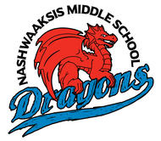
FAMILY ORIENTATION
We would like to invite Grade 5
Parents/Guardians & Students
to join us in the
Theatre at
Nashwaaksis Middle School
Monday, June 3th @ 6:30PM
for
Orientation into Grade 6 for
Fall 2019!
We look forward to seeing you all!
Thanks!
Kendra Frizzell, Principal
Marcie Connors, Vice Principal

